Realisation document: FoodBridge
By: Simeon Markov
Institution Name: Fontys UAS
Course/Class: ICT/EN08
Date: 2025-12-02

Introduction
This document highlights the project development phase, detailing the technical structure, implementation strategy and development workflow. It includes explanation of the core logic, explaining major parts of the architecture like controllers, views, components, writing and dealing with migrations (database changes, modifications).

Project structure
This section presents the system architecture and main components.
System architecture:
Architecture: React & Asp.NET (Client-Server communication)
- Backend: Asp.NET handles routing, controllers, models, validation
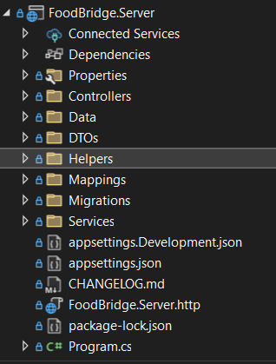
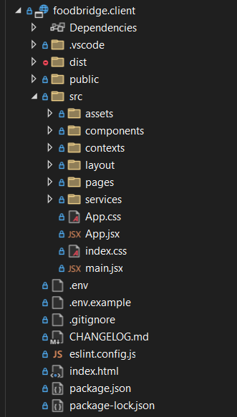
- Frontend: React handles frontend (React components).
Figure 2: Server-side structure
Figure 1: Client-side structure

UI Additions/Alterations
- Manage Resource: The manage resource page was modified to include a search bar and a filtration.
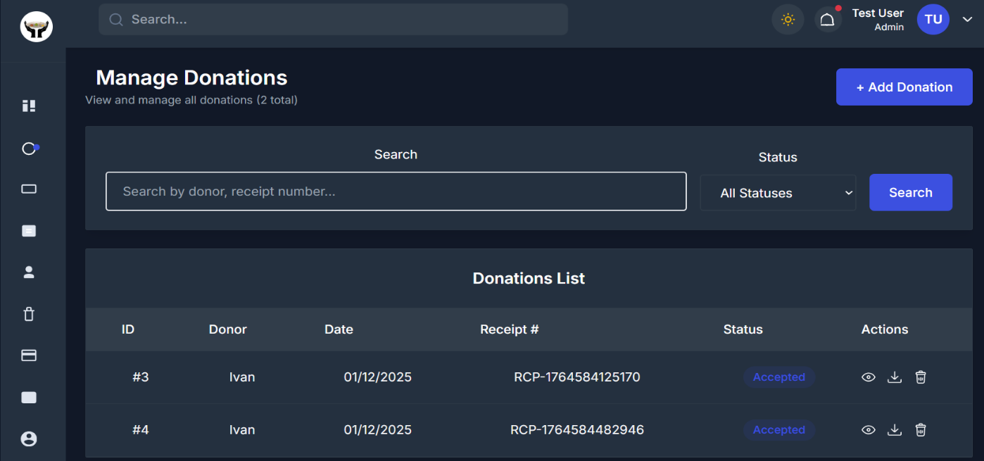
Figure 3: Manage resource page
The page contains internal links to create, edit, and delete a resource.

Code documentation

Main logic
This section explains the main logic behind the project (DotVVM three-tier architecture).
Example flow: First a model with a migration file is created, where the migration file is used to define the model objects, so that the ORM (Entity Framework in this case) could pass it as data object (code-first approach) and the model prepares the data that the application is going to work with (business layer). Then a react component reads from the entity, handles user’s requests, passes data to the defined controller, which then returns a response to the page.

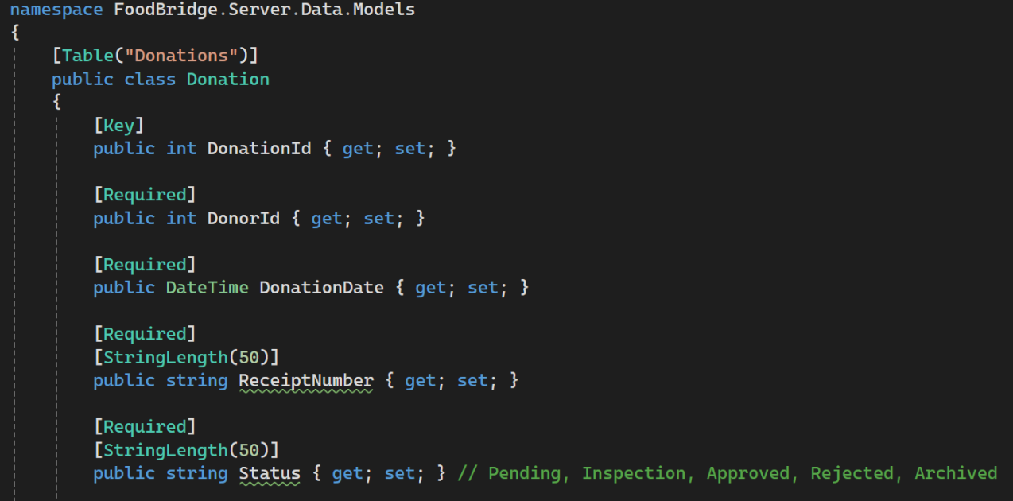
Figure 4: Donation entity defined
Explanation: Each field that will correspond to a column in the table is defined class of the object type (Donation -> Donations). Each annotation like Key, Required is a constraint for that column in the database.

Controllers: Exposing ASP.NET backend API for the server-side rendering.

NOTE: For extensive reading of the code documentation please visit: https://github.com/Simeon31/Pass-TheBall/tree/master.

Development methodology and techniques

Architectural Patterns & Principles
Category | Patterns/Principles
Patterns | Layered architecture, Domain-Driven Designinspired aggregates, Repository & Adapter patterns at boundaries, CQRS-lite for read-heavy timelines, Event-driven async processing for notifications/media
Principles | Separation of concerns, Single Responsibility, Dependency Inversion (services depend on contracts), Security by Design, Modularity with explicit interfaces, Fail-fast error handling,  Observability-first mindset
UI Patterns | UI components, Composition over inheritance,  Conventional slots/props for extendability
Table 2: Architectural Patterns & Principles

Conclusion
In conclusion, the project successfully implements a scalable, maintainable social platform with modern web technologies and architectural best practices, delivering a responsive user experience with real-time features and extensibility through modular design.

References/Sources
- AI Transparency: Perplexity AI for extensive research, summary & Claude AI as code helper (used for generating partial code of the overall project with set of instructions).
- YouTube video, inspired by: https://youtu.be/4iiEyOKhvao?si=vQARG5ZIs5uFc_jl .

